**BA/DA TRAINING**

**Assignment – 8(July16,2019)**

**SHAFALI GUPTA**

1. **Explain Maintenance.**

**Ans:-** An IT service provider suggest their clients to go for software maintenance services for the consistent and enhanced performance of the system. It keeps solutions healthy to deal with changing technical and business environment.

As IT is most updated industry domain, it introduces technical advancements almost every day that improve solution efficiency to streamline business operations. Under the maintenance management, system is updated with latest technologies on the regular basis and run with high-end efficiency. System maintenance involves improvements in the existing solution and at times there are requirements of new development as per the changing market needs. Software maintenance is a part of Software Development Life Cycle. Its main purpose is to modify and update software application after delivery to correct faults and to improve performance.

Software Maintenance is an activity that takes place once the operation is done. It optimizes the solution performance by reducing errors, eliminating useless development and applying advanced development. Solution development can take 1-2 years to build a system while software maintenance management can be an ongoing activity for 15-20 years. Software maintenance in [software engineering](https://en.wikipedia.org/wiki/Software_engineering) is the modification of a software product after delivery to correct faults, to improve performance or other attributes.

**Need of Software Maintenance-**

**1. Bug Fixing**

In maintenance management, bug fixing comes at priority to run the software seamlessly. This process contains search out for errors in code and correct them. The issues can be occurred in hardware, operating systems or any part of software.

**2. Capability Enhancement**

This comprises improvement in features and functions to make solution compatible with varying market environment. It enhances software platforms, work pattern, hardware upgrade, compilers and all other aspects that affect system workflow.

**3. Removal of Outdated Functions**

The unwanted functionalities are useless. Moreover, by occupying space in solution, they hurt efficiency of the solution. Using software maintenance procedure, such elements of UI and coding are removed and replaced with new development using the latest tools and technologies.

**4. Performance Improvement**

To improve system performance, developers detect issues through testing and resolve them. Data and coding restricting as well as reengineering are the part of software maintenance. It prevents the solution from vulnerabilities.

**Software Maintenance Services Categories:**

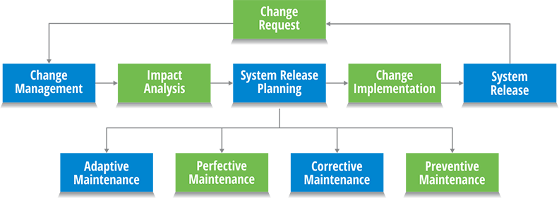

**1. Adaptive** – Modifications in system to keep it compatible with changing business and technical environment.

**2. Perfective** – Fine tuning of all elements, functionalities and abilities to improve system operations and perfectness.

**3. Corrective** – Detecting errors in the existing solution and correcting them to make it works more efficiently.

**4. Preventive** – Preventive software maintenance services help in preventing the system from any upcoming vulnerabilities.

**Maintenance Process-** Software maintenance activities include

1. **process implementation**- The implementation process contains software preparation and transition activities, such as the conception and creation of the maintenance plan. The preparation for handling problems identified during development and the follow-up on product configuration management.
2. **problem and modification analysis** - which is executed once the application has become the responsibility of the maintenance group. The maintenance programmer must analyze each request, confirm it by reproducing the situation and check its validity, investigate it and propose a solution, document the request and the solution proposal, and finally obtain all the required authorizations to apply the modifications.
3. **modification implementation** - The process considering the implementation of the modification itself
4. **maintenance review/acceptance -** The process acceptance of the modification, by confirming the modified work with the individual who submitted the request in order to make sure the modification provided a solution.
5. **migration** - The migration process is exceptional and is not part of daily maintenance tasks. If the software must be ported to another platform without any change in functionality, this process will be used, and a maintenance project team is likely to be assigned to this task.
6. **software retirement** - Finally, the last maintenance process, also an event which does not occur on a daily basis, is the retirement of a piece of software.

